Part 1 and Part 2
Q1)
Explain whether each of the scenarios below is a classification or regression problem. Indicate whether the main goal is inference or prediction, and specify n (number of observations) and p (number of features).
- A dataset of 1,000 patients is collected, including their age, weight, blood pressure, cholesterol level, and whether they developed heart disease within 5 years. The aim is to identify the factors most strongly associated with heart disease.
This problem is a classification problem because the output (the target) is either having a heart disease of not (yes/no)
The goal is to study all the factors to know which factors are the most affecting to having a heart disease (feature selection)
N (number of observations) = 1000 (records/datapoints)
P (number of features) = 4 features (age, weight, blood pressure, cholesterol)

- A real estate company records the sale prices of 5000 houses along with square footage, number of bedrooms, age of the property, and location rating, and wants to estimate the price of a newly listed house.
The problem is regression because the problem is to predict contentious values for every observation
The goal is to predict house prices using different features
N (number of observations) = 5000 (records/datapoints)
P (number of features) = 4 features (square footage, bedrooms, age, location rating)

- A dataset spanning five years since 2020 tracks the daily number of active users for an app, the total time spent on the application, peak usage hours during the day, and the most in-demand app features. The startup aims to forecast the number of active users and the total time spent on the application for the upcoming month.
The problem is regression because the output is continuous values of future time spent and users count
The goal is to forecast the future usage of the app and daily active users
N (number of observations) = 5 years of collected data each day counts as a record so a year consists of 365 days so 365 * 5 = 1825 (records/datapoints)
P (number of features) = 2 (peak usage hours, most in-demand app features)

Q2)
You are part of a research team designing an AI-powered medical diagnosis assistant. The system should handle the following tasks:
- Detect tumors in MRI scans.
Supervised learning (binary classification) since we need to detect if the MRI scans have tumor or not the labeled target
The chosen classification algo is to SVM classifier with RBF kernel, we used it because SVM classifier is best to use with high dimensional spaces and with small to medium datasets, also the RBF kernel is used to handle nonlinear boundaries in the medical MRI scans.
Training time complexity for SVM with RBF kernel is between:
O(m^3 * n) and O(m^2* n), where m = number of training samples, and n = number of features
Because optimization techniques like Sequential Minimal Optimization (SMO) work with a Gram/kernel matrix of size m*m, which the algorithm must compute and store. In the case of huge datasets (hundreds of thousands of samples), this fast becomes costly to compute.

Prediction time complexity:
O(nsv * n)
nsv = number of support vectors
n = number of features
Because MRI scans are high-dimensional and tumor-indicating patterns might be too sensitive and changeable for human norms, machine learning is crucial. Consistent, scalable prioritization is made possible via supervised learning, which enables the model to generalize to fresh scans after learning these patterns from labeled instances.

- Classify skin lesions into benign or malignant categories.
Supervised learning (binary classification) since we have two labels (benign or malignant)
The chosen model is random forest classifier. Random forest classifier has been chosen because it handles non-linear boundaries and strong in terms if dealing with noise and outlier datapoints, it typically generalize better than a single tree and offer built-in OOB (out-of-bag) validation for performance estimation.

Training time complexity:
A decision tree with n samples and m features its time complexity for a single is O(m * n * log(n)) and the random forest has T trees thus the random forest classifier training time complexity is O(T * n * m * log(n))
Prediction complexity:
Prediction for single tree is logarithmic O(longn) , since random forest classifier has multiple trees its prediction time complexity is O(T*logn)

Automated classification reduces variation among individuals by rapidly and accurately screening huge numbers of dermoscopic pictures. When clear rule-based solutions are challenging, machine learning (ML) stands out because it learns from examples and generates probabilistic outputs that you can threshold and assess using the appropriate metrics.

- Group patients with similar genetic profiles for personalized treatment suggestions.

Unsupervised learning (clustering) since we are grouping patients who have similar genetic profiles that requires finding hidden patterns
The chosen algorithm is K-means clustering algorithm so to group patients into genetically similar groups that can guide treatment, K-Means switches between allocating each patient to the closest centroid and calculating the centroids to minimize the within-cluster sum of squares. This is simply the pattern-discovery we seek.

Training time complexity:
O(n * k * d * i), where , n = number of datapoints, k = number of clusters, d = number of features, and i = number of iterations.

Prediction time complexity (assigning new points to a cluster):
O(k * d), k = number of clusters, d = number of features
Genomic data are very high-dimensional and unlabeled. In order for doctors to customize treatments for physiologically comparable patient groups, unsupervised learning (clustering) is crucial for finding organized genetic groupings.

- Predict the likelihood of a patient being readmitted to the hospital within 30 days.

Supervised learning (binary classification) since we are searching for the likelihood of if the patient should be readmitted or not (yes/no)
The chosen model is logistic regression. Logistic regression gives each case a probability score. You set a decision threshold that splits the cases into two groups: if a case’s score is at or above the threshold, assign the positive class; if it’s below, assign the negative class. And you can use AUC (area under the curve) to adjust the threshold to balance false positives and false negatives

Training time complexity (gradient descent):
O(n * d) per iteration, where n = number of datapoints, and d = number of features

Prediction time complexity:
For binary logistic regression O(d), where d = number of features
For multiclass logistic regression O(C * d), where C – number if classes, d = number of features

In order to allocate resources and focus follow-up treatment, hospitals require forward-looking risk forecasts. In order to meet clinical trade-offs (capture more at-risk patients vs. minimize false alarms), supervised classification algorithms translate EHR characteristics into calculated readmission probabilities and enable threshold modification using ROC/AUC.

- Detect faulty readings from wearable medical devices.

Unsupervised learning (clustering for anomaly detecting).
The used algorithm is K-means clustering algorithm. K-Means repeatedly assigns each reading to its nearest centroid and recomputes centroids, minimizing within-cluster variation. Readings that fall far from their cluster centroid can be flagged as faulty/outliers. If the number of normal behaviors
Training time complexity:
O(n * k * d * i), where , n = number of datapoints, k = number of clusters, d = number of features, and i = number of iterations.

Prediction time complexity (assigning new points to a cluster):
O(k * d), k = number of clusters, d = number of features
Continuous, noisy streams are produced by wearables without trustworthy (faulty/not-faulty) designations. Real-time quality control without manual labeling is made possible by unsupervised techniques, which are crucial for modeling common trends and identifying outliers that depart from learned clusters or centroids.

Q3)
Given a dataset with the following points, determine the weights w and bias b for the decision boundary of a linear SVM, and explain the process in detail.
X1 | X2 | Label
7 | 6 | -1
8 | 5 | -1
10 | 7 | 1
11 | 8 | 1

X1 | X2 | Label 1
7 | 6 | -1
8 | 5 | -1
10 | 7 | 1
11 | 8 | 1
SVM classification (hard margin) Linear SVM

W.X+b=0 yi(W.X+b) =1

Class (-1): (7,6), (8,5)
Class (1): (10,7), (11,8)

f(x)=W.X+b
If f(X)>0 = positive class, else negative class

Identify the support vectors

(8,5), (10,7) =$\sqrt{{(8-10)}^{2}+{(5-7)}^{2}}$=$\sqrt{{(-2)}^{2}+{(-2)}^{2}}$=$\sqrt{8}$
(8,5), (11,8) =$\sqrt{{(8-11)}^{2}+{(5-8)}^{2}}$=$\sqrt{{(-3)}^{2}+{(-3)}^{2}}$=$\sqrt{18}$
(7,6), (10,7) =$\sqrt{{(7-10)}^{2}+{(6-7)}^{2}}=\sqrt{{(-3)}^{2}+{(-1)}^{2}}$=$\sqrt{10}$
(7,6), (11,8) = $\sqrt{{(7-11)}^{2}+{(6-8)}^{2}}=$ $\sqrt{{(-4)}^{2}+{(-2)}^{2}}$=$\sqrt{20}$
Then identify the support vector (closed points from different classes) (8,5), (10,7)

Now margin equality for the selected support vectors
$X^{-}$=for (8,5) label -1
$X^{+}$= for (10,7) label +1
W. $X^{-}$=-1
W. $X^{+}$=1

Subtract W ($X^{-}-X^{+}$)=-1-1
W ($X^{-}-X^{+}$)= -2
W (8-10), (5-7) =-2
W (-2, -2) =-2
W (1,1) =1

- Because vector W must be perpendicular to (1,1)

W=α (1,1)
α (1,1). (1,1) =1
(1,1) +(1,1) =2
So, W (1,1) =1
So 2α=1 α=1/2

- The direction of the optimal SVM vector must be parallel to (1,1)
Writing W=α (1,1) means
W points along with (1,1) but its length is still unknown

α= scale (magnitude)
W. $X^{+}+b$=1 W. $X^{-}+b$=-1
W ($X^{+}-X^{-}$)= 2
W(10,7) – (8,5) =2

W(2,2)=2 W(1,1)=1
Since W= α(1,1) α(1,1).(1,1)=1
α (1+1)=1
α (2)=1
α=1/2
So W=(1/2,1/2)

To find b
W($X^{+})=1$
½(10+7)+b=1
½ (17/2)+b=1
½(17/2)+b=1
b= 1-(17/2)
(2-17)/2=-15/2=-7.51
So=-7.5

To find the decision boundary
W/(X)+b=0
½ $X^{+}$+½$X^{-}$ $-$7.5=0
*2 (½ $X^{+}$+½$X^{-}$ $)$=(7.5 *2)
$X^{+}$+$X^{-}$ = 15
$\left(\frac{X1+X2}{2},\frac{y1+y2}{2}\right)$
$\left(\frac{8+10}{2},\frac{5+7}{2}\right)$ = $\left(\frac{18}{2},\frac{12}{2}\right)$ = (9,6)
The midpoint
X1+X2=15
9+6=15

Very constraints:
(W.X -7.5)
W=1/2
(10,7) ½(10+7)-7.5=(17/2)-7.5=(17-15)/2=2/2=1
(11,8) ½(11+8)-7.5=(19/2)-7.5=(19-15)/2=4/2=2 outside margin
(8,5) ½(8+5)-7.5=(13/2)-7.5=(13-15)/2=-2/2=-1
(7,6) ½(7+6)-7.5=(13/2)-7.5=(13-15)/2=-2/2=-1

Margin width = $\frac{2}{\left\|W\right\|}$ = $\frac{2}{\sqrt{({1/2)}^{2}+{(1/2}^{2})}}$= $\frac{2}{\sqrt{(1/4+1/4)}}$=$\frac{2}{\sqrt{2/4}}$=$\frac{2}{\sqrt{2}/2}$=$\frac{4}{\sqrt{2}}$
Midpoint = pins the location of the boundary and helps compute b
Margin width: qualifies how wide the separation is ( )
Maiming the margin width is the objective of SVM to get better generalization

Q4)
Why does applying the sigmoid function in logistic regression allow the model to perform multiclass classification? Give an example. Can you still use the sigmoid function for multiclass classification? Explain the reasoning.

Logistic regression computes a linear score for each example, given by s=W^T (x)+b This score represents the log-odds of the positive class and is assumed to be a linear function of the input features. The parameters are estimated using maximum likelihood, which in practice is equivalent to minimizing cross-entropy (log-loss) on the training data. The resulting model defines a linear decision boundary in the feature space.

Workflow for Binary Classification

The sigmoid function transforms the linear score into a probability between 0 and 1 in a binary classification context, such as predicting whether a patient would be readmitted within 30 days (yes/no). After that, a decision threshold is used, which is often set by default at 0.5. The model forecasts the negative class if the anticipated probability is less than or equal to the threshold, and the positive class otherwise. Additionally, thresholds can be changed based on trade-offs unique to a certain domain, such as giving recall precedence over precision. ROC curves, AUC, or other assessment measures are frequently used to advise these modifications. For instance, the patient would be categorized as "readmitted" if the threshold is set at 0.5 and the model produces a probability of 0.72.
The One-vs-Rest (OvR) approach is another way to use the sigmoid function in a multiclass context. This method treats one class as "positive" and all other classes as "negative," training a single binary logistic regression model for each class. The class with the greatest probability is chosen, and each model generates a unique sigmoid probability. Although this approach is effective, the probabilities do not add up to one since they are not jointly standardized. This is equivalent to setting multi_class='ovr' in scikit-learn.

Q5)
Using the dataset below, compute entropy and information gain for each feature. Draw the decision tree learned from this data without pruning.
BMI | Blood pressure | Family History (Heart Disease) | Stroke
N | N | N | N
L | H | Y | N
L | H | Y | N
H | H | N | Y
H | N | N | Y
N | N | Y | N
H | N | Y | Y
L | H | N | Y
L | H | N | Y
N | N | N | N

Class / target (stroke y, stroke N)

Probability of a class (Pc)
Pc =$\frac{number class}{number of data point }$
Probability of a class (y) Py=5/10=0.5
Probability of a class (N) PN=5/10=0.5
Entropy: impurity / uncertainty measure (H(s))
H(S) = - ∑ Pc.$\log_{2}{Pc}$
If all are the same class H=0
For information gain:
Feature X with values V (e.g X BMI with $\left\{N,L,H\right\}$)
Child subset for value v.Sv = $\left\{rows in S with X = v \right\}$
Information gain of splitting S on X:
IG (X; S) = H(s) - ∑ $\frac{\left|Sv\right|}{\left|S\right|}×H(Sv)$

1.Entropy H(s)
Stroke y: 4,5,7,8,9 = 5 rows
Stroke N: 1,2,3,6,10 = 5 rows
Total number or rows = 10 rows

Py=5/10=0.5
Pn=5/10=0.5
H(s)=-(0.5$×\log_{2}{0.5}+0.5×\log_{2}{0.5})$
$$\log_{2}{0.5}=-1$$
H(s)=-(0.5(-1)+0.5(-1)=-2(0.5)
H(s)=-(-1)=1
H(s)=1
2. gain information for each feature
BMI ∈ $\left\{N,H,L\right\}$ child entropy
BMI = N rows 1,6,10 = $\left\{N,N,N\right\}$
H(SN)=0(pure) 1 $\log_{2}{1}=0$
BMI= L rows 2,3,8,9 = $\left\{N,N,y,y\right\}$
H(SL)=1
0.5 $\log_{2}{0.5+}\log_{2}{0.5}$=1

BMI: H rows :4,5,7 = $\left\{Y,Y,Y\right\}$ 1 $\log_{2}{1}=0$
Whited child entropy
H(s)=0
3/10(0) +4/10(0) +3/10(0) =0+(4/10) +0=0.4
IG(BMI)=1-0.4
=0.6(Root entropy - ∑Sr/S*H (S child)
2. Blood pressure $\left\{N,H\right\}$
BP=N rows :1,5,6,7,10 $\left\{N,Y,N,Y,N\right\}$
PN=3/5 PY=2/5

-(3/5 $\log_{2}{3/5}$ +2/5$\log_{2}{2/5)}$=0.971
PH = rows 2,3,4,8,9 $\left\{N,N,Y,Y,Y\right\}$=0.971
5/10 (0.971) +5/10(0.971) =0.971
IG (BD)=1-0.971=0.029

3. Family History $\left\{Y,N\right\}$

FH=N rows :1,4,5,8,9,10 $\left\{N,Y,Y,Y,Y,N\right\}$
FH=Y rows :2,3,6,7 $\left\{N,N,N,Y\right\}$

PN=2/6 PY=4/6

-(2/6 $\log_{2}{2/6}+4/6\log_{2}{4/6}$)=0.811=PN
PY=3/4 PY=1/4
-(3/4$\log_{2}{3/4}+1/4\log_{2}{1/4}$)
PY=0.918 child entropy =4/10(0.918) +6/10(0.811)
=0.875
IG (FH) =1-0.875=0.125
IG (BMI)=0.6
IG(FH)=0.125
IG(BP)=0.029

3. Grow full tree without pruning

Starting with BMI (higher IG)
BMI ∈ $\left\{N,L,H\right\}$

For BMI
(N) rows :1,6,10 $\left\{N,N,N\right\}$ pure BMI=L no stroke
(L) rows :2,3,8,9 $\left\{N,N,Y,Y\right\}$ not pure
So, we split take only rows (2,3,8,9)

BMI(L) 2,3,8,9 $\left\{N,N,Y,Y\right\}$
The goal is to choose the feature with the largest information gain

At BMI=L
PY=2/4 PN=2/4
Entropy =-(0.5 -$\log_{2}{0.5+0.5}\log_{2}{0.5)=1}$

Now the remaining features
Blood pressure (BP) ∈ $\left\{N,H\right\}$
Family history (FH) ∈ $\left\{N,Y\right\}$

 | BP | FH | Stroke | BMI
2 | H | Y | N | L
3 | H | Y | N | L
8 | H | N | Y | L
9 | H | N | Y | L

For BP H L for all data points
One child = 4/4=1
Child entropy = 4/4*1-0/4*0
Child entropy =1

IG=1-1=0
BP gives no separation

Use family history to split

BMI | FM | Stroke
L | Y | N
L | Y | N
L | N | Y
L | N | Y

FH(Y)N rows 2,3 $\left\{N,N\right\}$ pure
FH(N) rows 8,9 $\left\{Y,Y\right\}$ pure

Child entropy = SFH =Y=0 since pure
SFH=N=0 since pure

Child 1
For FM=Y rows 2,3 $\left\{N,N\right\}$
PN=2/2=1 PY=0/2=0
-(2/2 $\log_{2}{2/2+0\log_{2}{0)=0}}$

Child 2
For FH=N rows 8,9 $\left\{Y,Y\right\}$
PY=2/2, PN=0/2
-(0$\log_{2}{0+2/2\log_{2}{2/2}}$)=0
Child (1) entropy =0 child (2) entropy =0

Weighted child entropy =2/4(0) +2/4(0) =0
Entropy =1
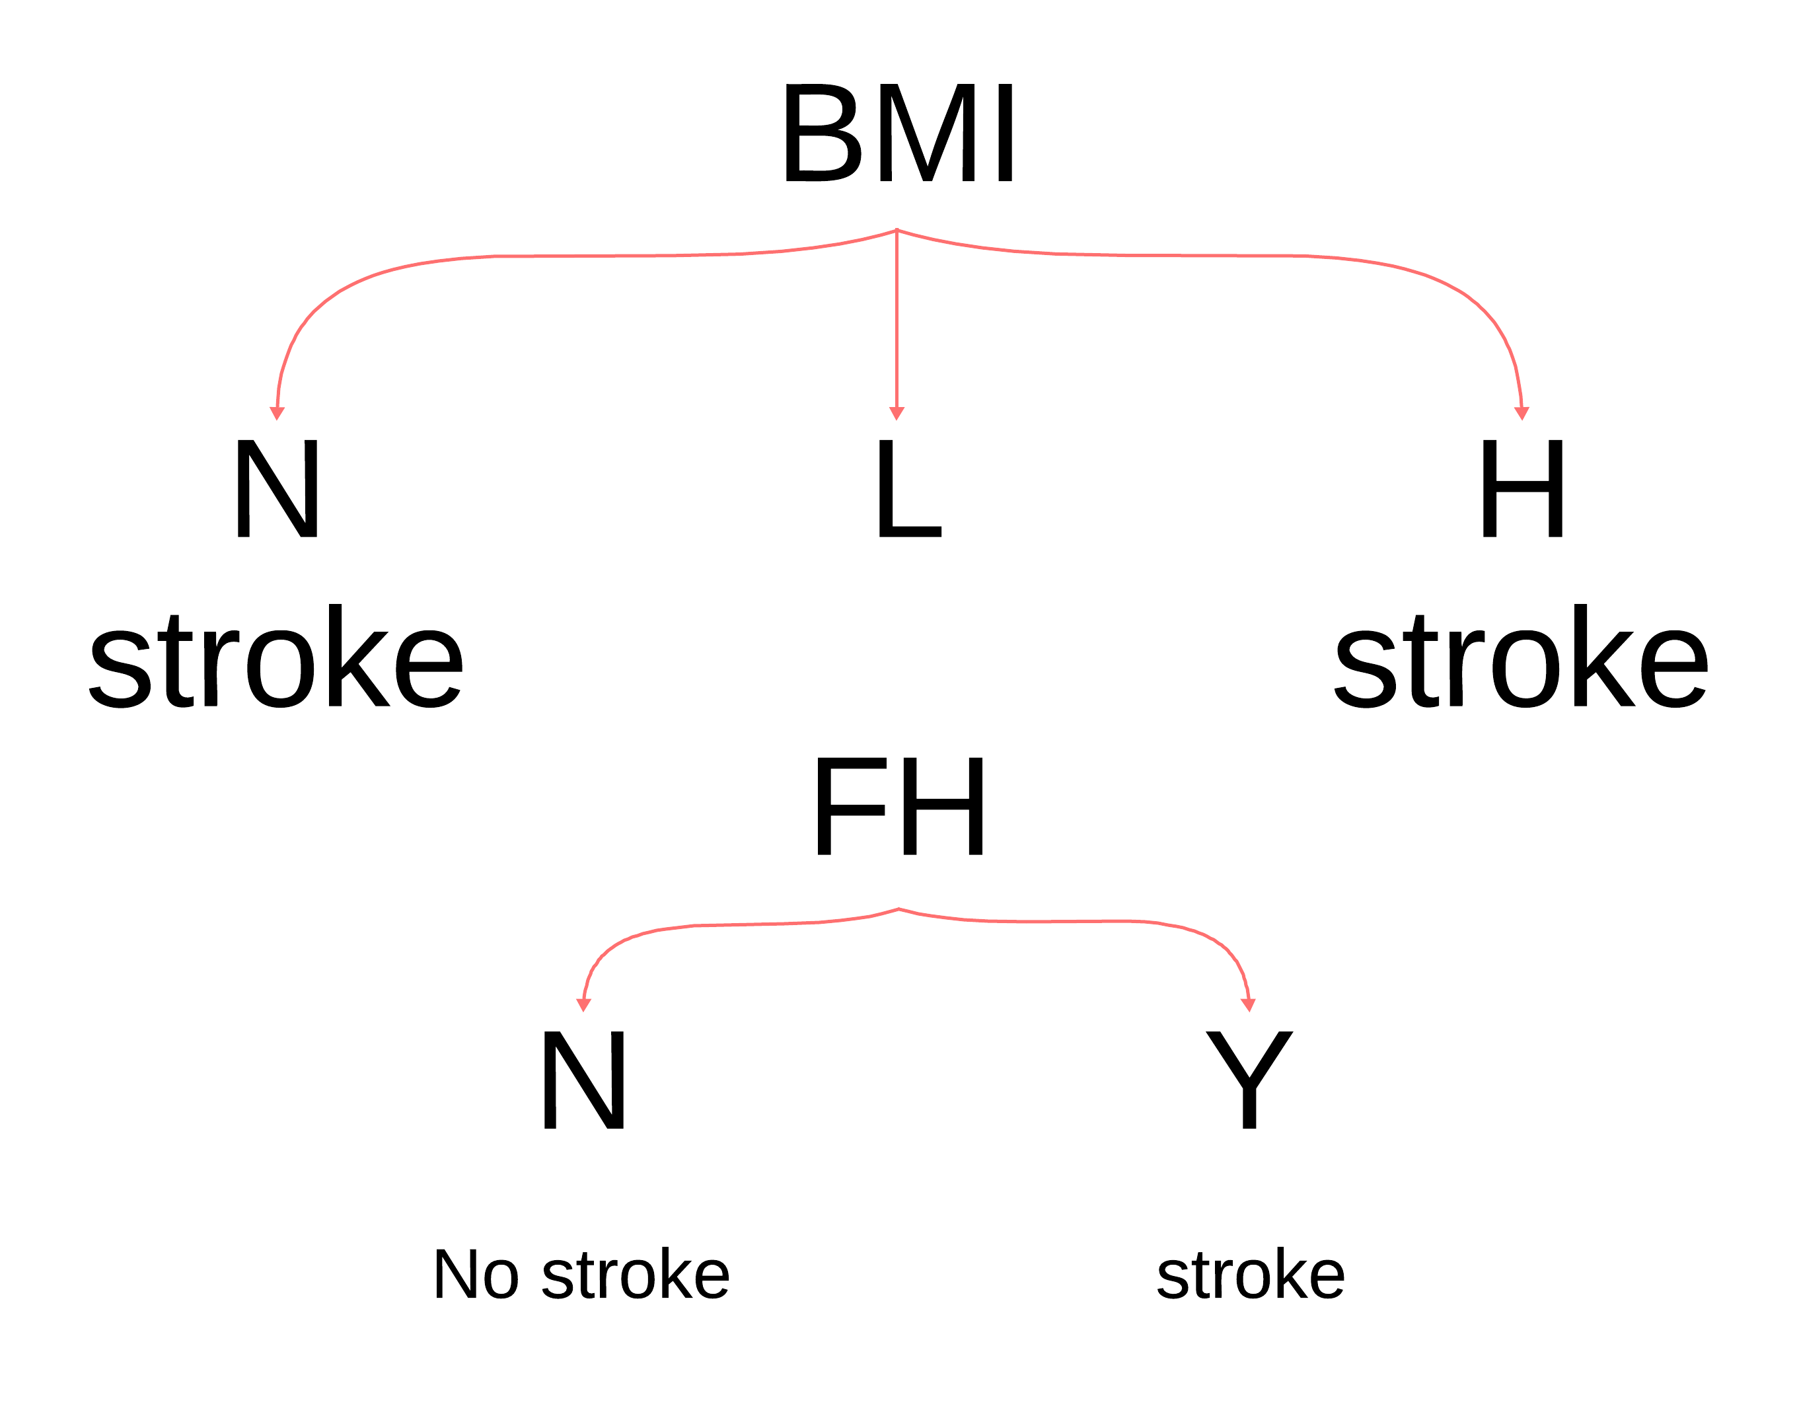
Weighted child entropy =0

IG =1-0=1 perfect split

(H) Rows :4,5,7 $\left\{Y,Y,Y\right\}$ pure
Entropy =0 if BMI H (stroke)

Q6)
A logistic regression model is fitted for student exam success:
X1​ = hours studied, X2 = number of practice exams taken, Y = pass (1) or fail (0).
Estimated coefficients: B0=−4, B1=0.04, B2=0.6
- Estimate the probability of passing for a student who studies 50 hours and takes 4 practice exams.
- Find the minimum number of practice exams needed for a student who studies 30 hours to have at least a 70% chance of passing.
X1=hours studied
X2=number practice exams
Y 1: pass ,0: fail
B0=-4 B1=0.04 B2=0.6
Estimated coefficients:

Multiple logistic regression:
2=B0+B1X1+B2X2 this gives probability between [0,1]

Probability formula (binary logistic regression)
P(Y=1|X1, X2) =1/(1+$e^{x}P(-Z)$
Z=B0+B1X1+B2X2
Logit inversion:
Logit (P)=Ln(P/(1-P)) =Z

- Probability of passing
X1=50,X2=50
Z=B0+B1X1+B2X2
Z=-4+0.04(50)+0.6(4)=-4+2+2.4=0.4
Z=0.4

P=1(1+$e^{-0.4})$
$e^{-0.4}=0.67$
1/0.67=0.598
Probability of passing = 59.8%
2. Minimum number of practice exams to 70% pass with 30 hours of studying
X1=30
-4+(4(30))/100 + (6(X2))/10
=-2.8+(6X2)/10
Z=Ln P/(1-P) = Ln 0.7/(1-0.7) =0.7/0.3=7/3=0.8

Z=0.847

-2.8+(6X2)/(10)=0.847
X2=(3.647(10))/6=36.47/6
=6.079

Need more than 6 exams to achieve 70% probability of passing

Why not (6)
If X2=6

-4+(0.04(30))+0.6(6)
=-2.8+3.6=0.8
1/(1-$e^{-0.8})$=0.689 not 0.7

Q7):
Consider a simple regression problem with the following data:
Instance | True Value
1 | 10
2 | 15
3 | 20

You are using gradient boosting with the following setup:
- Initial Prediction: f₀(x)=12 for all instances.
- Learning Rate: η=0.1.
Tasks:
- Calculate the initial residuals after f₀(x).
- Update predictions after the first weak learner.
- Compute the residuals for the second iteration.
- Update predictions after the second weak learner.
- Explain how the algorithm improves the prediction after each iteration?
-initial prediction:
f(x)=12,for all instances
-learning rate :η=0.1
For each stage :
1.computr residuals
r=actual-predicted
${ri}^{m}=Yi-fm-1(Xi)$
2.fit a weak learner to residuals
3.update fm(X)=fm-1(X)+ η hm(X)
Constant
Hm(X)=Cm
Mean of residuals to minimize mean squared error
Data Y=[10,15,20]
Fo(X)=12 , η=0.1

- Calculate the initial residuals after fo(X)
fo(X)=12
Instance | actual | Predicted | Residuals
1 | 10 | 12 | 10-12=-2
2 | 15 | 12 | 15-12=3
3 | 20 | 12 | 20-12=8

$$r^{1}=Yi-fo(X)$$
$$r^{1}=[-2,3,8]$$
- Update residuals after the first weak learner
C1=-2+3+8/3=9/3=3

F1(X)=fo(X)+ η*C1
=12+0.1(3)=12.3
F1(X)=12.3

- Compute the residual for the second iteration

$$r^{2}=Yi-f1(X)$$
10-12.3=-2.3
15-12.3=2.7
20-12.3=7.7
$$r^{2}=\left[-2.3,2.7,7.7\right]$$

- Update predictions after the second weak learner
C2=-2.3+2.7+7.7/3=8.1/3=2.7
F2(X)=fo(X)+ η*C2
=12.3+0.1(2.7)=12.57
F2(X)=12.57

Q8)
Below is a description of three machine learning (ML) applications integrated with your Gmail account to filter and delete spam emails. For each application, compute the True Positive Rate (TPR) and False Positive Rate (FPR). Then, describe how the corresponding point would appear on the ROC curve and explain under what circumstances ROC analysis provides more insight than a confusion matrix.
Application A: After testing with 50 emails—25 of which were actually spam and 25 non-spam—the results were as follows: The recall was 76%, and the F1-score was approximately 82.4%.
Application B: After testing with 50 emails—25 of which were actual spam and 25 non-spam—the results were as follows: The recall was 88%, and the precision was 84%.
Application C: After passing the following test emails, the results were as below. S denotes a spam email, while N refers to a non-spam (important) email.
Actual | S | S | S | S | S | S | S | S | S | S | S | S | S | S | S | S | S | S | S | S | S | S | S | S | S
Predicted | S | S | S | S | S | S | S | S | N | S | S | N | S | S | S | S | S | S | S | S | S | S | S | S | S

Actual | N | N | N | N | N | N | N | N | N | N | N | N | N | N | N | N | N | N | N | N | N | N | N | N | N
Predicted | S | S | N | S | N | N | N | S | N | N | N | N | S | N | N | S | N | N | N | N | N | N | N | N | N

How the points sit on the ROC & when ROC helps more than a confusion matrix
- A: (0.08,0.76)(0.08, 0.76)(0.08,0.76) low FPR, moderate TPR.
- B: (0.16,0.88)(0.16, 0.88)(0.16,0.88) higher TPR than A, but also higher FPR.
- C: (0.24,0.92)(0.24, 0.92)(0.24,0.92) very high TPR, but also the highest FPR.
ROC shows the trade-off as you change the threshold (the same classifier will trace a curve as you sweep the threshold). Your slides’ ROC section stresses: thresholds can (and should) be adjusted depending on whether FP or FN is more costly for the application. A single confusion matrix locks you to one threshold, so it can’t show that trade-off

Compute True Positive Rate (TPR/) and False Positive Rate (FPR).

Spam → Positive class , Non-Spam → Negative class

TPR → Recall FPR → F1-Score

ROC: Receiver Operating Curve

AUC: Area under the Curve

TP: P spam and it is spam
FP: P spam and it is non-spam
TN: P non-spam and it is non-spam
FN: P non-spam and it is spam

TPR (Recall) = (TP)(TP+FN)

FPR = (FP)(FP+TN)

Precision = (TP)(TP+FP)

F1-Score =( 2.Precision . Recall)/(Precision + Recall)

ROC & AUC
ROC curve: plots TPR vs FPR (lowering/raising the threshold of FN vs FP)
AU : a number summarizes the whole ROC (the higher the AUC the better)
AUC used to compare models (good for imbalanced datasets)
AUC is better than Accuracy / single confusion matrix

App A
50 emails → 25 Spam, 25 Non-Spam
Recall = 76% , F1-score = 82.4%
→ Use recall to find TP, FN
Recall=T/25=0.76
Since the sum of Spam = 25, then TP+FN=25
TP=25(0.76)=19=TP
25=TP+FN
FN=25−TP
FN=6

Find Precision using F1 and Recall
F1-score= 2⋅Precision⋅Recall/ Precision +Recall
0.824= 2⋅Precision(07.6) /0.76 +Recall

Precision=F1.R/2R-F1
=0.824(0.76)/2(0.76)-0.824​

Precision= 0.9
​

Find FP and TN from Precision
Precision= TP/ TP+FP
0.9=19/19+FP
FP=2.11≈2
TN=25−FP⇒TN=25−2=23
TN=23
Compute TPR & FPR
TPR(Recall)= 19/25=0.76
FPR=FP/FP+TN=2/2+23=2/25=0.08
​ROC point (FPR, TPR):
(0.08,0.76)

APPB
50 emails
25spam,25 non-spam
Recall =88%
Precision=84

Find TP, FN from Recall
Recall=TP/25
0.88(25)=22
TP=22
25-22=3
FN=3
​

Find FP, TN from Precision
Precision= TP/TP+FP
0.84= 22/22+FP
FP=(22/0.84)-22=4.19=4​
25=TN+FP
TN=25-4=21

Find TPR & FPR
TPR=Recall=0.88
FPR= FP/FP+TN​
FPR = 4/4+21
FPR =0.16
ROC point (FPR, TPR):
(0.16,0.88)

APP C
25spam 25non-spam
in actual Spam

predicted spam =23
TP=23
FN=2
TPR=23/25=0.92

in actual non- Spam
non- Spam=10 TN=19 FP=6
FPR=6/25=0.24
ROC point (0.24,0.29)

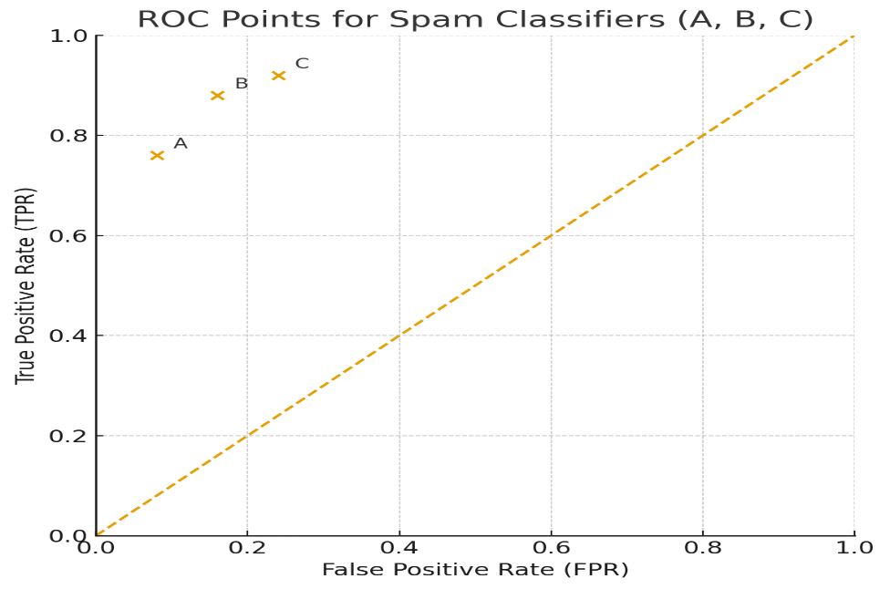
The ROC (Receiver Operating Characteristic) curve is a graphical tool used to evaluate the performance of a binary classifier. It plots the True Positive Rate (TPR, or recall) on the y-axis against the False Positive Rate (FPR) on the x-axis at various classification thresholds.

A point closer to the top-left corner (high TPR, low FPR) represents a stronger model.

The diagonal line from (0,0) to (1,1) represents a random classifier; any model performing above this line is better than random guessing.

In our case:

- Application A → (0.08, 0.76) balances low FPR with moderate TPR.
- Application B → (0.16, 0.88) increases recall but at the cost of more false positives.
- Application C → (0.24, 0.92) has the highest recall but also the highest FPR.
This shows the trade-off between catching spam (TPR) and wrongly flagging important emails (FPR).

Q9)
What are the key signs of underfitting and overfitting during the model evaluation process? What are the primary causes of overfitting, and how can it be mitigated? Provide at least three techniques

Underfitting:
When the model is too basic to accurately represent the true relationships in the data, underfitting happens. When the hypothesis space is so small that even patterns found in the training set are not correctly learnt, this is referred to as a high-bias issue. A low training score and a low validation/test score are the primary indicators of underfitting, which occurs when the model performs poorly on any dataset. As model complexity rises, learning curves usually show both the training and validation curves converge at a low score. Underfitting basically means that the model lacks crucial structure, which leads to poor generalization on training and unknown data.
To mitigate underfitting, several strategies can be applied. Increasing model capacity by moving to a more expressive algorithm such as moving from linear regression to polynomial regression can help the model capture more complex relationships.
Another solution is feature engineering: adding domain-specific or interaction features that make important signals accessible to the model.
Reducing regularization strength can also be effective, since too much regularization constrains the model unnecessarily. Additionally, training for longer or incorporating more data can help iterative learners such as neural networks. Finally, ensembles like boosting are designed to reduce bias by combining weak learners into stronger ones. In practice, validation curves guide this process: if both train and validation scores are low, the remedy is to increase complexity until performance improves.

Overfitting:
An overly complicated model that learns the noise in the training data rather than the actual underlying signal is said to be overfitting. This failure pattern has high-variance in terms of the bias–variance tradeoff. A very high training score coupled with a much lower validation/test score which denotes poor generalization are the telltale indications. As model complexity increases, learning curves usually reveal that the validation curve falls while the training curve stays high. While overfitted models work well on training data, they don't work well on fresh, untested data.
Several causes contribute to overfitting. Using an excessively complex model for instance, a high-degree polynomial when only a simple relationship exists encourages the model to memorize noise. Small datasets or datasets with irrelevant features also increase the risk, since the model tries to fit details that don’t generalize. Long training times without proper monitoring, or data leakage where test information influences training, are further causes. Overfitting is also common in high-dimensional datasets, where the number of features is large compared to the number of samples, leading to the curse of dimensionality.

To combat overfitting, techniques such as regularization (L1, L2, or elastic net) add penalties to discourage overly complex models. Cross-validation helps in choosing appropriate hyperparameters and avoiding over-tuning to a single dataset.
Early stopping during training prevents models from continuing past the point where validation performance declines. Feature selection and dimensionality reduction remove irrelevant predictors and reduce noise, addressing the high-dimensionality problem.
Ensembles like bagging and boosting can improve generalization when tuned carefully. Finally, simplifying the model by reducing the number of features or lowering polynomial degree can directly reduce variance. To combat overfitting, techniques such as
regularization (L1, L2, or elastic net) add penalties to discourage overly complex models.
Cross-validation helps in choosing appropriate hyperparameters and avoiding over-tuning to a single dataset.
Early stopping during training prevents models from continuing past the point where validation performance declines. Feature selection and dimensionality reduction remove irrelevant predictors and reduce noise, addressing the high-dimensionality problem.
Ensembles like bagging and boosting can improve generalization when tuned carefully. Finally, simplifying the model by reducing the number of features or lowering polynomial degree can directly reduce variance.
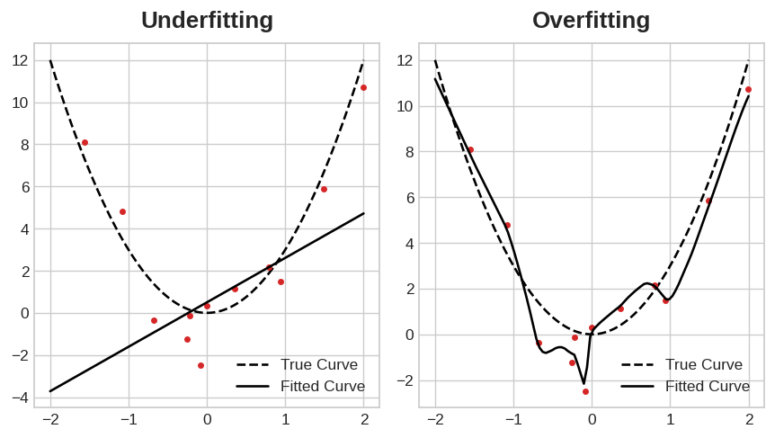

Q10)
The table below presents the wholesale prices of commercial goods (in thousand JOD), based on the total quantity of items sold. Use an appropriate machine learning approach (either regression or classification) to complete Table 2, which contains the total sales of items. Your task is to predict the required wholesale price (in thousands of JOD) for each item. Use a suitable evaluation metric to assess the accuracy of your predicted results and the performance of the machine learning model.
Table 1: Training Data Set
quantity of items sold | wholesale prices
5 | 26
8 | 38
6 | 30
11 | 50
7 | 34
12 | 54
4 | 22
9 | 42
13 | 58
3 | 18
14 | 62

Table 2: Testing Data Set
quantity of items sold | Predicted | Actual
25 |  | 108
83 |  | 335
94 |  | 370

because using one feature
Price = β0 + β1 · quantity
y = mX + b
X : quantity y : price

- Compute means
Xˉ=∑Xi/n=5+8+6+11+7+12+4+9+13+3+14/11
Xˉ=8.36
- (scalled covariance for least squares)
Sxy=∑(Xi−Xˉ)^ 2140.54
(Yi−Yˉ) ^ 2562.18

- Compute coefficient
β1=Sxy/Sxx=562.18/140.54=4
βo= Yˉ-β Xˉ=39.45-4(8.36)=6
price = βo+ β1X
price=6+4(X)
predicted | Actual | Residuals
6+4(25)=106 | 108 | 108-106=2
6+4(83)=338 | 335 | 335-338=-3
6+4(94)=382 | 370 | 370-382=-12
Model evaluation
MSE,RMSE,$R^{2}$
MSE=1/$m\sum_{i=1}^{m}{e^{2}}$
RMSE=$\sqrt{MSE}$ ​
$$R^{2}=1-\frac{\sum{e_{i}^{2}}}{\sum{(Yi-Yˉ)^2}}$$

Residuals [2, -3, -12]
$$e^{2}[4,9,144]$$
$$\sum{e^{2}=4+9+144=157}$$
MSE=157/3=52.33
RMSE=$\sqrt{MSE}$ ​=$\sqrt{52.33}=7.23$
$$R^{2}=1-\frac{157}{\sum{(Yi-Yˉ)^2}}$$
​
$$Yˉ=\frac{370+335+108}{3}=271$$
$$R^{2}=1-(SSF/SST)$$
Where SSF=$\sum{e_{i}^{2}}=157$

SST=(108-271)^2+(335-271)^2+(370-271)^2=40866
$$R^{2}=1-(157/40866)=0.996$$

Q11)
You are given the following observed and predicted values for a regression model:
Observed | Predicted
2 | 1.8
3 | 3.1
5 | 4.9
7 | 6.8
8 | 8.0

Tasks:
- Calculate the mean of observed values.
- Compute SST, SSE, and R^2.
- Interpret R^2 in context.

The percentage of variability in the observed values of Y that the model can account for is represented by the coefficient of determination, or R 2. The model in this instance explains almost 99.6% of the variance in the dataset, with R 2 = 0.996 and R 2 ≈ 0.996. This suggests that the anticipated and observed values fit each other incredibly well.
Using the formula R2 = 1 – SSE/SST R 2 = 1 − SST SSE, the computation is based on sums of squares. Then. R 2 = 1−0.10/26≈0.996 is the result of the calculation using your values, SSE = 0.10 and SST = 26. The model's mistakes are insignificant in relation to the overall distribution of the data since the sum of squared errors (SSE) is so small in comparison to the total sum of squares (SST).

Notwithstanding this high R2, there are crucial disclaimers to be aware of. First, because there are only five points in the dataset, the small sample size may cause R 2 to seem exaggerated. To better assess generalization, it is therefore always a good idea to evaluate the model using a hold-out dataset or cross-validation. Second, the appropriateness of the model shape is not always confirmed by a high R 2 value. To make sure the fit is not deceptive and that assumptions are satisfied, residual plots and diagnostics should be examined. Spurious connections are a well-known illustration of this risk: two variables may fit well together without actually having a causal link.

It is also helpful to remember that R 2 values can be negative if the model performs worse than the mean, vary from 1 for a perfect fit to 0 when a model simply predicts the mean, and so on. Results are sanity-checked with the aid of this context. Consequently, even while the result (R 2 ≈0.996) indicates that the model accounts for almost all of the data variability, it should not be interpreted as a guarantee of causal insight or prediction accuracy. To make sure that the performance is accurate and dependable, it is important to combine these findings with residual analysis, validation on unobserved data, and meticulous model review.

$$Yˉ=(2+3+5+7+8)/5=25/5=5$$

sum square residuals
SST $\sum{e^{2}}$
(2−1.8)^2+(3−3.1)^2+(5−4.9)^2+(7−6.8)^2+(7−6.8)^2+(8-8)^2=0.1

SST (total sum of squares)
$$\sum{(Yi-Yˉ)^2}$$
$Yi$ =actual(observed)
$\sum{(Yi-Yˉ)^2}$=((2−5)^2+(3−5)^2+(5−5)^2+(7−5)^2+(8−5)^2
=(−3)^2+(−2)^2+0+2^2+3^2=9+4+4+9=26
$$R^{2}=1-\left(0.1/26\right)=0.9962$$

Q12)
Fit two polynomial regression models for the dataset below, compute predictions, R2 and RSS for both, and decide which model fits better (Interpret the results).
Model 1: Y=2+1X+1X^2
Model 2: Y=1+1.5X+0.5X^2+0.1X^3

X | Y
1 | 3
2 | 8
3 | 15
4 | 24
5 | 35

Model 1 :Y=X^2+X+2
Model 2: Y=0.1X^3+0.5X^2+1.5X+1
X | Y | Ŷ | e = Y - Ŷ | e²
1 | 3 | 4 | -1 | 1
2 | 8 | 8 | 0 | 0
3 | 15 | 14 | 1 | 1
4 | 24 | 22 | 2 | 4
5 | 35 | 32 | 3 | 9

Yˉ=17=58/5​
SST = ∑(Yi−Yˉ)^2
=(3−17)^2+(8−17)^2+(15−17)^2+(24−17)^2+(35−17)^2
=(−14)^2+(−9)^2+(−2)^2+(7)^2+(18)^2
=196+81+4+49+324
SST=654

For both models
RSS model = ∑(Y−Y^)^2=(3−4)^2+(8−8)^2+(15−14)^2+(24−22)^2+(35−32)^2
=1+0+1+4+9=15
$$R^{2}=1-(15/654)=0.9771$$

Model 2
X | Y | Ŷ | e = Y - Ŷ | e²
1 | 3 | 3.1 | -0.1 | 0.01
2 | 8 | 6.8 | 1.2 | 1.44
3 | 15 | 12.7 | 2.3 | 5.29
4 | 24 | 21.4 | 2.6 | 6.76
5 | 35 | 33.5 | 1.5 | 2.25

RSS (SSE) = (3−3.1)^2+(8−6.8)^2+(15−12.7)^2+(24−21.4)^2+(35−33.5)^2
=0.01+1.44+5.29+6.76+2.25=15.75
$$R^{2}=1-\left(15.75/654\right)=0.9759$$
Model (1) is better than Model (2)
Model (1) > Model (2)
Which model fits better? (and why)
- Model 1 wins on both metrics: lower RSS (15 vs 15.75) and higher R2R^2R2 (0.9771 vs 0.9759).
- Interpretation (slides): R2R^2R2 is the proportion of variability in YYY explained by the model; both are very high (≈ 98%), but Model 1 explains slightly more variation with fewer terms (quadratic vs cubic).
- Pipeline wisdom from your polynomial-regression slides: greater flexibility (higher degree) can reduce error on some datasets, but it also risks unnecessary complexity/overfitting; choose the model that gives better validation error with no extra complexity. Here, even on this small set, the simpler quadratic performs marginally better—so prefer Model 1.
If you were selecting formally, your slides recommend the train/validate pipeline (compare models on a validation set using MSE/RSS, then test). We followed the same spirit by comparing RSS and R2R^2R2 head-to-head
R2 and the distribution of Y:
To evaluate the performance of the two polynomial regression models, we use the coefficient of determination (R2). This metric measures how much of the variability in the observed dependent variable (Y) is explained by the fitted model. In other words, R2 compares the regression model’s residual error (RSS) against the total variation in Y (SST). A higher R2 means that the model captures more of the distribution and spread of the actual Y-values.
For Model 1 (Y=X2+X+2Y = X^2 + X + 2Y=X2+X+2), the residual sum of squares (RSS) is 15, while the total sum of squares (SST) is 654. This gives an R2R^2R2 value of 0.9771, meaning that 97.7% of the variation in Yis explained by the quadratic model. The remaining 2.3% is unexplained, reflecting small deviations from the fitted curve.
For Model 2 (Y=0.1X3+0.5X2+1.5X+1Y = 0.1X^3 + 0.5X^2 + 1.5X + 1Y=0.1X3+0.5X2+1.5X+1), the RSS is slightly higher at 15.75, which leads to an R2 of 0.9759. This indicates that 97.6% of the variation in Y is explained by the cubic model, leaving about 2.4% unexplained.
When comparing the two, Model 1 achieves a marginally better fit, with a lower RSS and a higher R2. Although the difference is small, it shows that the quadratic model aligns more closely with the actual distribution of Y values than the cubic model. Importantly, this suggests that introducing the extra cubic term does not improve explanatory power in fact, it slightly reduces it. This result also demonstrates a key principle in regression: increasing complexity does not always yield better alignment with the target distribution and may risk overfitting

PART-3: Problem statement
1. Provide a well-defined problem statement with a clear set of requirements
Define a clear problem to solve using machine learning. Discuss all the details of the problem, such as the number of classes in a classification problem and each category (classification)), and any other important detail.
Problem statement:
Liver diseases represent a significant global health challenge, with conditions such as hepatitis, fatty liver disease, cirrhosis, and liver cancer leading to high morbidity and mortality rates. Since rapid treatment can greatly enhance patient outcomes, early and accurate detection is essential. However, delays or incorrect diagnoses may result from the failure of traditional diagnostic techniques like imaging and blood tests to clearly distinguish between different disease groups.
Creating a prediction system that can categorize individuals into certain categories based on their liver health state is the aim of this machine learning challenge. The target variable is used to represent various liver condition categories in this classification problem. For example:
0: no liver disease, 1: having liver disease
Requirements:
    - Accuracy and Recall: the system must have a high accuracy since such a problem needs to be careful precise when dealing with patients, also recall is important focusing in lowering the number of false negatives is important, it is dangerous to predict a patient that has a liver disease to classify the patient that he has no liver disease.

    - Interpretability: since medical applications require trust and transparency, the model should provide insights into the most influential features (age, genetic risk, alcohol consumption, liver enzyme levels).

    - Scalability: the model must be able to handle large number of patients datasets including different factors such as lifestyle, genetic data, clinical and demographic factors.

    - Generalization: the model should find a general and global solution , so if the model is applied on another portion of patients, it can achieve similar results.

- Find the best ML algorithms used to train models for such a problem.

      - Logistic regression: it is good when using it with binary and multiclass classification problems, show the contribution of each predictor towards the outcome, and it is better to use when the relationships between the predictors and the target is around linear relationship

  - Decision tree: It captures nonlinear relations between the predictors and the target, useful when using it with medical problems because is can set clear rules

  - Random forest: the use of the ensemble method that improves on decision trees by reducing overfitting, good with noisy/high dimensional datasets, and provides feature importance to identify the most affecting features

  - Support vector machine: It is better to use with high dimensional datasets that require complex models to find its hidden relationships, and it can distinguish between overlapping classes

  - Gradient boosting: Use it with complex classification problems, reduces bias and improving accuracy.

3. Compare the ML algorithms found and make a summary of their advantages/disadvantages. Use this to justify your choice of the algorithms you are going to use. Use a table for comparison.

Model | Advantages | Disadvantages
Logistic regression | Simple and interpretable provides probability outputs, fast to train | Assumes linear relationships limited in capturing complex patterns
Decision tree | Easy to understand and visualize, handles nonlinear relationships | Prone to overfitting unstable with small data changes
Random forest | Reduces overfitting, robust to noise, provides feature importance | Less interpretable than single trees computationally more intensive
Support vector machine | Effective in high-dimensional spaces handles nonlinear data with kernels | Sensitive to parameter tuning slow on very large datasets
Gradient boosting | High predictive accuracy, reduces bias and variance, handles complex patterns | Requires careful tuning more computationally expensive

Justifications for the selected algorithms/models:
    - Random forest classifier is strong and prevents overfitting, provides feature importance, which is important for medical problems, so it is good in setting rules.
    - boosting is known for predictive accuracy and is widely used in healthcare prediction tasks.
These two models balance performance and generalization, making them strong candidates for classifying liver disease across multiple categories.

PART-4: Model Development
1. Identify and obtain a relevant dataset for training models to address the problem at hand. Provide a detailed description of the dataset, including its source, method of collection, key attributes, size, and the domain it represents.
The dataset used for this project is titled (Liver_disease_data.csv), specifically curated for educational and modeling purposes in the medical domain. It is intended to support research and experimentation in predictive modeling for liver disease detection.
Source and collection method:
Instead of actual healthcare records, the dataset is a specially selected set that is made publicly available (on Kaggle) for scholarly purposes. It combines clinical, genetic, lifestyle, and demographic characteristics that are frequently linked to the risk of liver disease. Based on laboratory findings and patient health tests, the data replicates actual medical characteristics.

Domain:
This dataset belongs to the medical/healthcare domain, focusing on hepatology (the study of liver-related conditions).

Size:
The dataset contains 1,700 patient records and 11 attributes in total

Key attributes:
Demographic Features:
- Age (numerical) : Patient’s age in years.
- Gender (binary: 0 = female, 1 = male).

Lifestyle Features:
- BMI : Body Mass Index.
- AlcoholConsumption : Average alcohol intake level.
- Smoking : Binary indicator of smoking habits.
- PhysicalActivity : Level of physical activity.

Genetic/Medical History Features:
- GeneticRisk : Binary indicator of hereditary predisposition.
- Diabetes : Binary indicator of diabetes status.
- Hypertension : Binary indicator of hypertension status.

Clinical Feature:
- LiverFunctionTest: Quantitative measure of liver function levels.

Target Variable:
Diagnosis – Binary classification label:
  - = Liver disease present, 0= No liver disease

  - Prepare the dataset by performing the necessary preprocessing and splitting it into training, validation, and test subsets.

Data cleaning:
- Verified that there were no missing values in the dataset.
- Checked for duplicate rows and removed them to avoid bias during training.

Feature encoding:
- The Gender column, originally represented as 0 (female) and 1 (male), was retained as binary numeric values suitable for model input.
- Other categorical/binary attributes (Smoking, GeneticRisk, Diabetes, Hypertension) were already in numeric form and required no additional encoding.

Feature scaling:
- Numerical variables (Age, BMI, AlcoholConsumption, PhysicalActivity, LiverFunctionTest) were standardized using z-score normalization to ensure that all features contributed equally to model training.

Data splitting:
The dataset was divided into three subsets:
- Training set (60%) Used to train the models.
- Validation set (20%) Used for hyperparameter tuning and model selection.
- Test set (20%) Held out to evaluate the final performance of the selected models.
- Stratified sampling was applied to maintain the class balance of liver disease (1) vs. no disease (0) across all subsets.

3. Train the models designed for making inferences and solving the problem under consideration. Show the steps for training and use screenshots from your code.

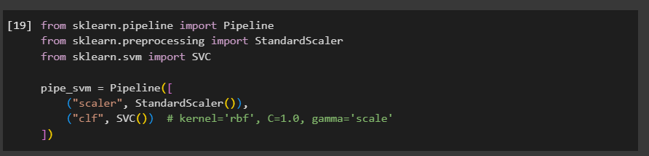
Data preparation & pipeline concept: Standardizing features (e.g., with StandardScaler) before model fitting to ensure all features contribute on the same scale. Pipelines are used to chain preprocessing and the estimator to avoid leakage and keep CV clean.

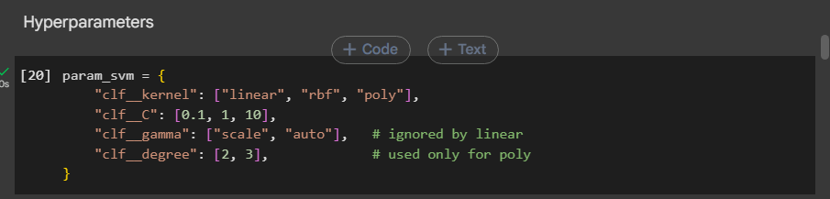
Cross‑validation & scoring: Setting up GridSearchCV with cv=5 (or similar) and a scoring dictionary. Refitting on 'recall' prioritizes catching positives (low false negatives). Timing (t0/t1) measures grid runtime.

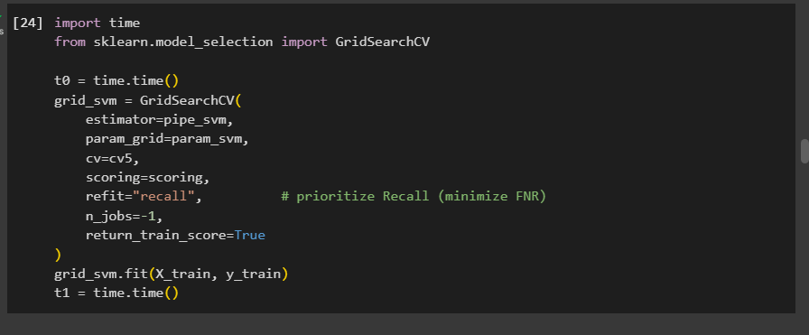
SVM hyperparameter grid: Exploring kernel (linear/rbf/poly), C (regularization), gamma (RBF/poly width), and degree (for poly). Lower FNR (1 − recall) is better; ties can be broken by accuracy/F1.

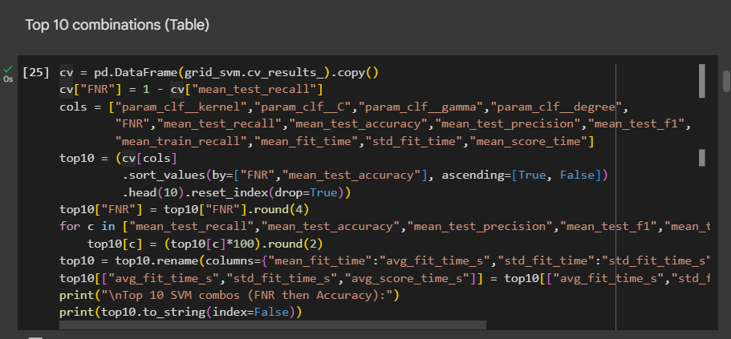
SVM best model & validation metrics: Reporting best_params_, CV recall, possible over/under‑fit gap (train vs CV), and validation performance (recall, FNR, accuracy, F1, confusion matrix, classification report).

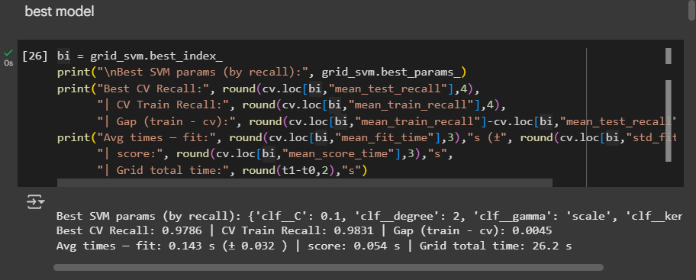
SVM held‑out test metrics: Final unbiased evaluation on X_test to confirm generalization.

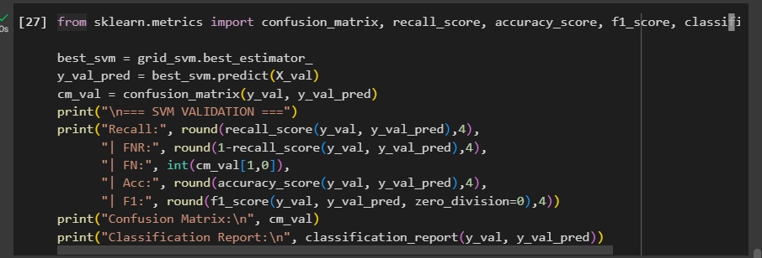
Logistic Regression grid: Trying solvers/penalties (lbfgs+l2, liblinear+l1/l2) and C values (e.g., 0.1, 1, 10). Pipelines ensure scaling consistency across CV folds.

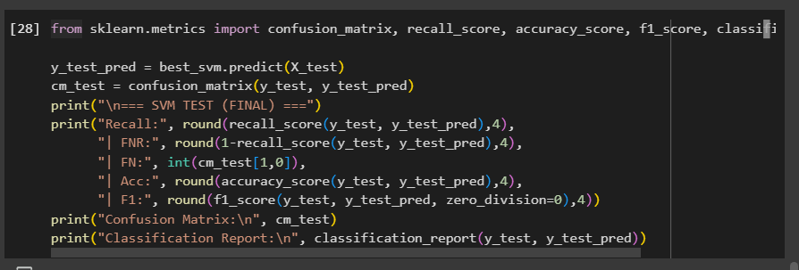
Logistic Regression validation results: Select best LR by recall; inspect precision/recall/F1 balance and confusion matrix.

Decision Tree grid: Tuning criterion (gini/entropy), max_depth, min_samples_split, min_samples_leaf. Control depth/leaves to avoid overfitting.

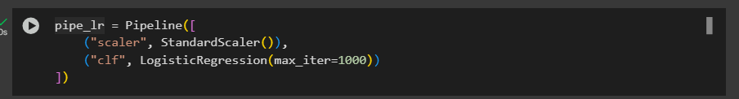
Decision Tree results: Report best DT settings, validation metrics, and note variance/instability risks vs. bias control.

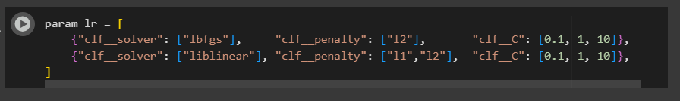
Random Forest grid: Tuning n_estimators, max_depth, min_samples_* and max_features ('sqrt'/'log2'). Averaging across trees lowers variance; monitor recall/FNR.

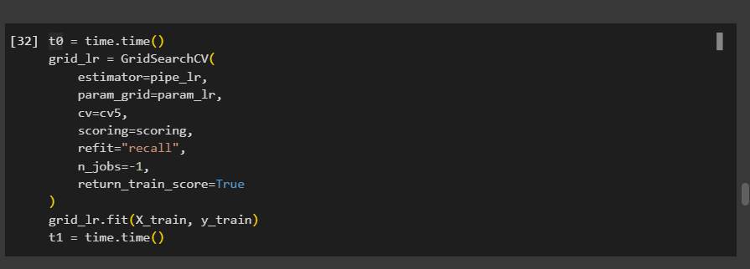
Random Forest results: Feature‑bagging effects seen in confusion matrix; check recall gains vs. complexity/time.

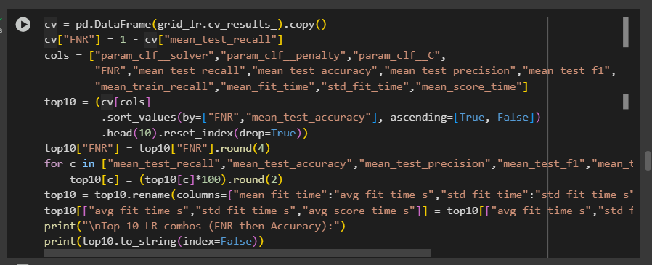
Gradient Boosting grid: Tuning n_estimators, learning_rate, and base tree depth (max_depth). Lower learning_rate with more estimators often stabilizes generalization.

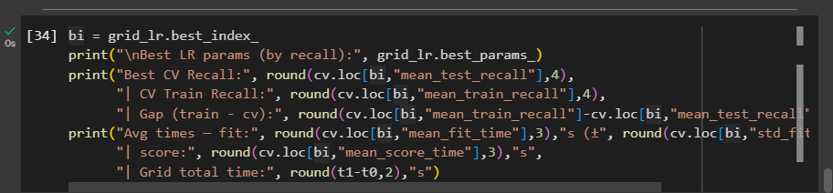
Gradient Boosting results: Best GBM summary with validation metrics; compare recall/FNR to other models.

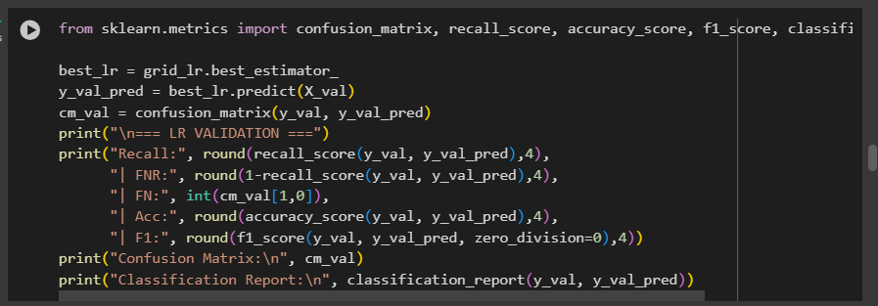
Training step: Grid search over hyperparameters, model selection by recall (to minimize FNR), and evaluation using validation/test splits with confusion matrix and classification report.

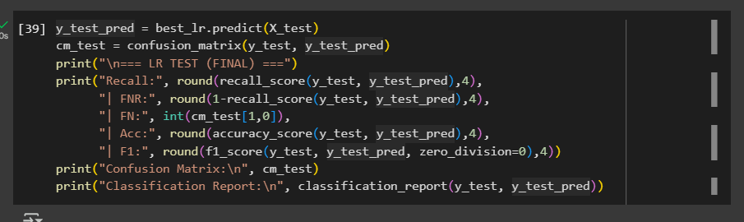
Training step: Grid search over hyperparameters, model selection by recall (to minimize FNR), and evaluation using validation/test splits with confusion matrix and classification report.

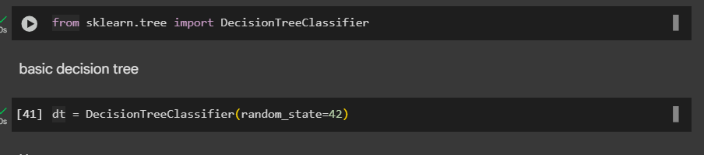
Training step: Grid search over hyperparameters, model selection by recall (to minimize FNR), and evaluation using validation/test splits with confusion matrix and classification report.

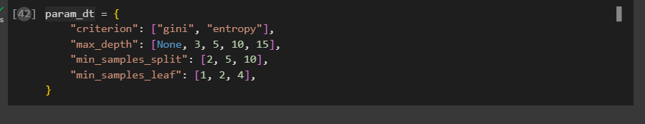
Training step: Grid search over hyperparameters, model selection by recall (to minimize FNR), and evaluation using validation/test splits with confusion matrix and classification report.

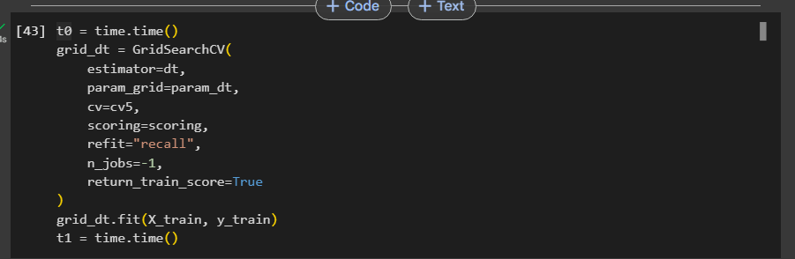
Training step: Grid search over hyperparameters, model selection by recall (to minimize FNR), and evaluation using validation/test splits with confusion matrix and classification report.

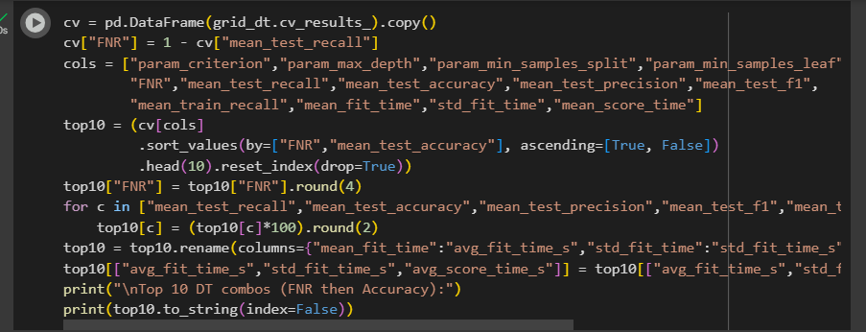
Training step: Grid search over hyperparameters, model selection by recall (to minimize FNR), and evaluation using validation/test splits with confusion matrix and classification report.

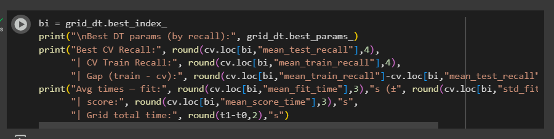
Training step: Grid search over hyperparameters, model selection by recall (to minimize FNR), and evaluation using validation/test splits with confusion matrix and classification report.

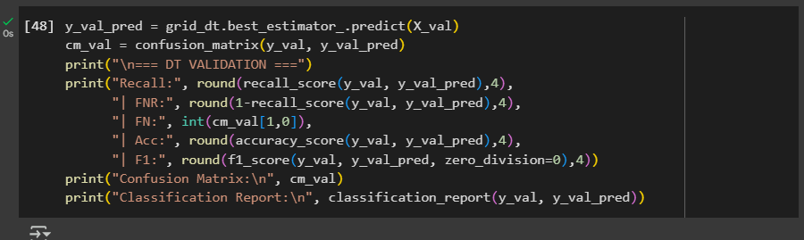
Training step: Grid search over hyperparameters, model selection by recall (to minimize FNR), and evaluation using validation/test splits with confusion matrix and classification report.

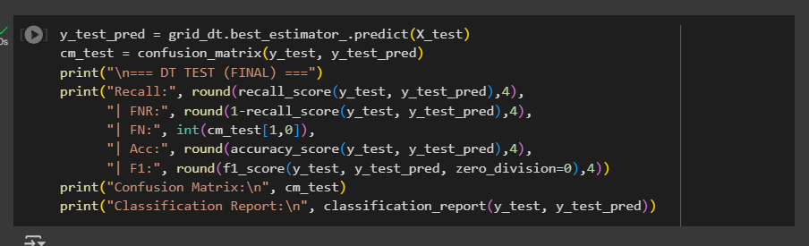
Training step: Grid search over hyperparameters, model selection by recall (to minimize FNR), and evaluation using validation/test splits with confusion matrix and classification report.

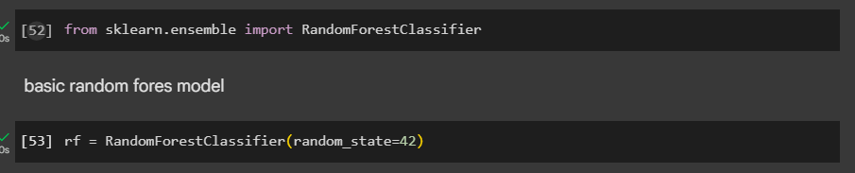
Training step: Grid search over hyperparameters, model selection by recall (to minimize FNR), and evaluation using validation/test splits with confusion matrix and classification report.

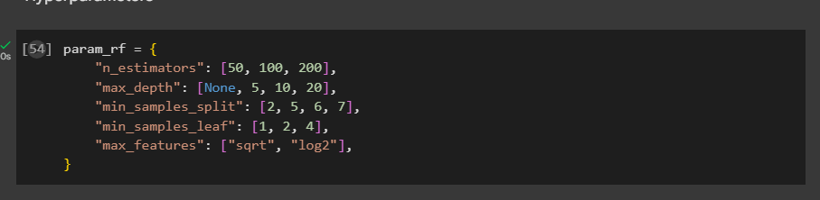
Training step: Grid search over hyperparameters, model selection by recall (to minimize FNR), and evaluation using validation/test splits with confusion matrix and classification report.

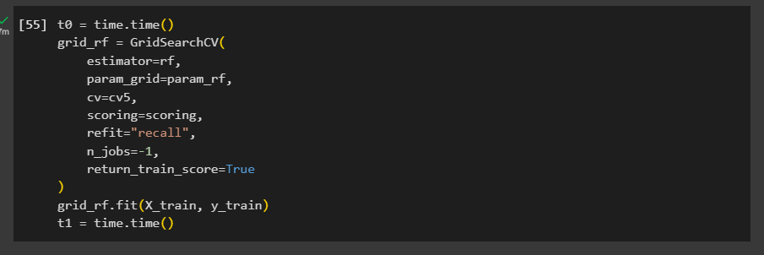
Training step: Grid search over hyperparameters, model selection by recall (to minimize FNR), and evaluation using validation/test splits with confusion matrix and classification report.

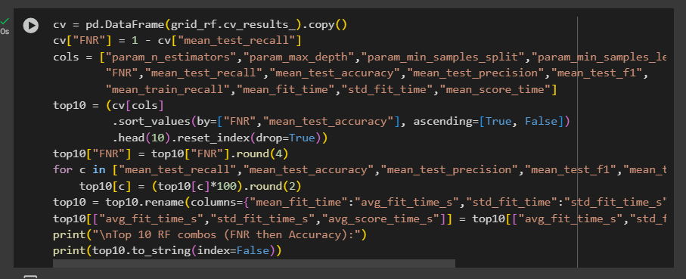
Training step: Grid search over hyperparameters, model selection by recall (to minimize FNR), and evaluation using validation/test splits with confusion matrix and classification report.

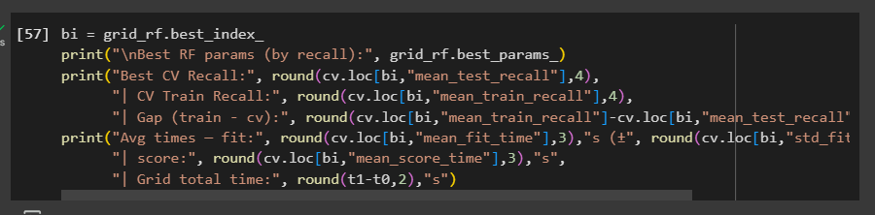
Training step: Grid search over hyperparameters, model selection by recall (to minimize FNR), and evaluation using validation/test splits with confusion matrix and classification report.

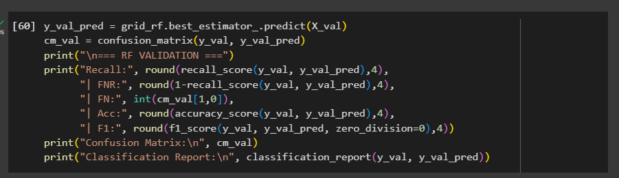
Training step: Grid search over hyperparameters, model selection by recall (to minimize FNR), and evaluation using validation/test splits with confusion matrix and classification report.

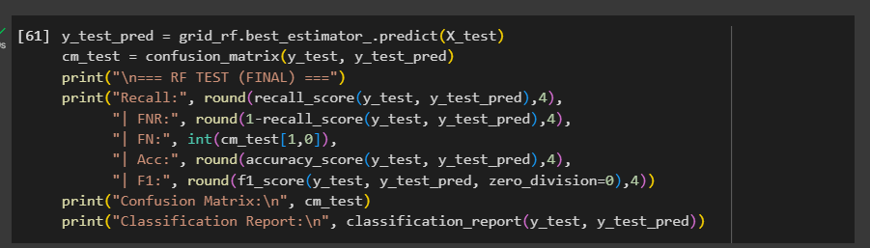
Training step: Grid search over hyperparameters, model selection by recall (to minimize FNR), and evaluation using validation/test splits with confusion matrix and classification report.

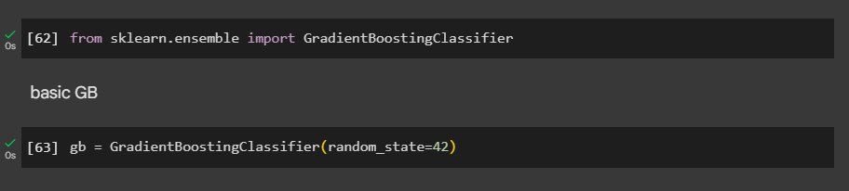
Training step: Grid search over hyperparameters, model selection by recall (to minimize FNR), and evaluation using validation/test splits with confusion matrix and classification report.

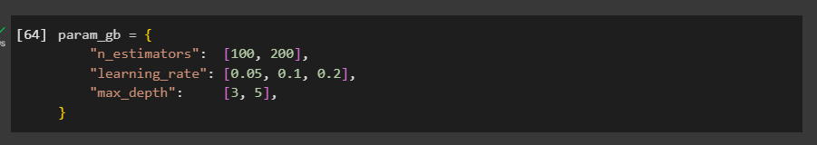
Training step: Grid search over hyperparameters, model selection by recall (to minimize FNR), and evaluation using validation/test splits with confusion matrix and classification report.

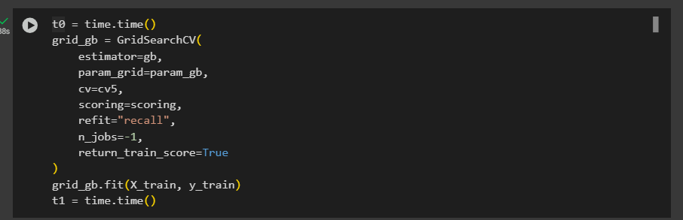
Training step: Grid search over hyperparameters, model selection by recall (to minimize FNR), and evaluation using validation/test splits with confusion matrix and classification report.

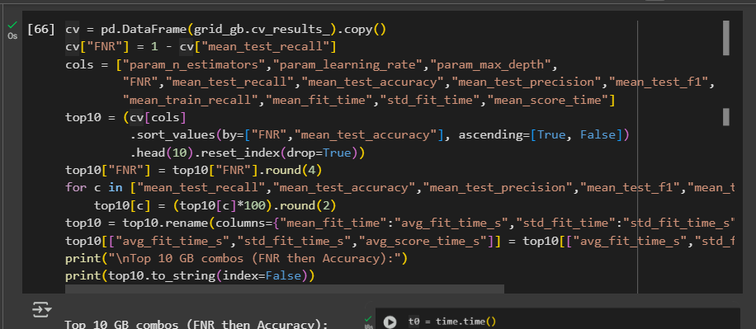
Training step: Grid search over hyperparameters, model selection by recall (to minimize FNR), and evaluation using validation/test splits with confusion matrix and classification report.

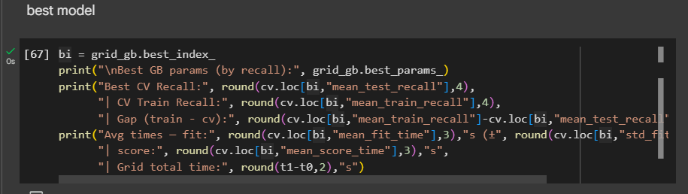
Training step: Grid search over hyperparameters, model selection by recall (to minimize FNR), and evaluation using validation/test splits with confusion matrix and classification report.

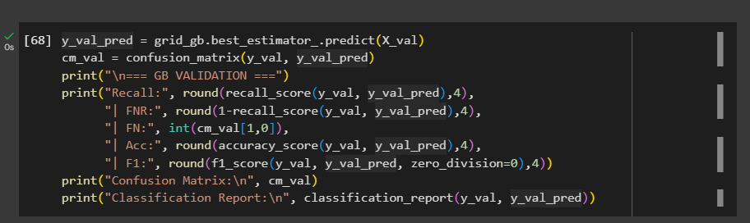
Training step: Grid search over hyperparameters, model selection by recall (to minimize FNR), and evaluation using validation/test splits with confusion matrix and classification report.

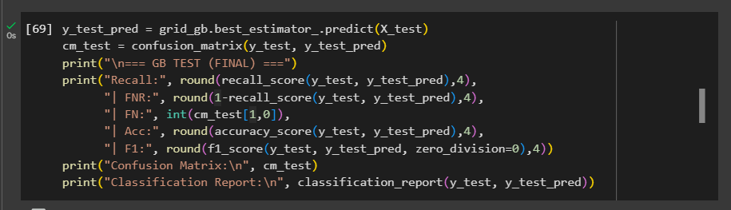
Training step: Grid search over hyperparameters, model selection by recall (to minimize FNR), and evaluation using validation/test splits with confusion matrix and classification report.

Summary of the training workflow:
1) Split the dataset into train/validation/test.
2) Built scikit‑learn Pipelines to standardize features and fit models safely inside cross‑validation.
3) Used GridSearchCV with cv=5 and a scoring dictionary, refitting the model that maximized recall to reduce FNR.
4) For each algorithm (SVM, LR, DT, RF, GB), ran grid search, ranked results by FNR then accuracy, and reported the top combinations.
5) Extracted the best estimator for each family, computed validation metrics (recall, FNR, accuracy, F1, confusion matrix), then evaluated once on the held‑out test set for the final report.
6) Interpreted gaps between train vs CV/test recall to comment on under/overfitting behavior.

4. Provide a comprehensive explanation of the training process, including the hyperparameters considered and their values, the algorithms selected, and any other relevant details. Use a table to summarise your selections.
Table: Description of the hyperparameters considered and best value for each hyperparameter or hyperparameter combination.
Algorithm | Hyper-parameter | Description | Value
SVM | kernel, C, gamma, degree | Combo #1 (Top-10 by FNR) | poly, 0.1, scale, 2
SVM | kernel, C, gamma, degree | Combo #2 | rbf, 0.1, scale, —
SVM | kernel, C, gamma, degree | Combo #3 | rbf, 0.1, auto, —
SVM | kernel, C, gamma, degree | Combo #4 | linear, 0.1, —, —
SVM | kernel, C, gamma, degree | Combo #5 | rbf, 1, scale, —
SVM | kernel, C, gamma, degree | Combo #6 | rbf, 1, auto, —
SVM | kernel, C, gamma, degree | Combo #7 | linear, 1, —, —
SVM | kernel, C, gamma, degree | Combo #8 | linear, 10, —, —
SVM | kernel, C, gamma, degree | Combo #9 | rbf, 10, scale, —
SVM | kernel, C, gamma, degree | Combo #10 | rbf, 10, auto, —
Logistic Regression | solver, penalty, C | Combo #1 (Top-10 by FNR) | lbfgs, l2, 0.1
Logistic Regression | solver, penalty, C | Combo #2 | liblinear, l1, 10
Logistic Regression | solver, penalty, C | Combo #3 | lbfgs, l2, 1
Logistic Regression | solver, penalty, C | Combo #4 | liblinear, l1, 1
Logistic Regression | solver, penalty, C | Combo #5 | liblinear, l2, 10
Logistic Regression | solver, penalty, C | Combo #6 | liblinear, l2, 1
Logistic Regression | solver, penalty, C | Combo #7 | lbfgs, l2, 10
Logistic Regression | solver, penalty, C | Combo #8 | liblinear, l2, 0.1
Logistic Regression | solver, penalty, C | Combo #9 | liblinear, l1, 0.1
Logistic Regression | solver, penalty, C | Combo #10 | lbfgs, l2, 0.5
Decision Tree | criterion, max_depth, min_samples_split, min_samples_leaf | Combo #1 (Top-10 by FNR) | entropy, 5, 2, 1
Decision Tree | criterion, max_depth, min_samples_split, min_samples_leaf | Combo #2 | entropy, 10, 2, 1
Decision Tree | criterion, max_depth, min_samples_split, min_samples_leaf | Combo #3 | gini, 5, 2, 1
Decision Tree | criterion, max_depth, min_samples_split, min_samples_leaf | Combo #4 | gini, 5, 5, 1
Decision Tree | criterion, max_depth, min_samples_split, min_samples_leaf | Combo #5 | entropy, 10, 5, 1
Decision Tree | criterion, max_depth, min_samples_split, min_samples_leaf | Combo #6 | gini, 10, 2, 1
Decision Tree | criterion, max_depth, min_samples_split, min_samples_leaf | Combo #7 | gini, None, 2, 1
Decision Tree | criterion, max_depth, min_samples_split, min_samples_leaf | Combo #8 | entropy, 5, 5, 1
Decision Tree | criterion, max_depth, min_samples_split, min_samples_leaf | Combo #9 | gini, 10, 5, 1
Decision Tree | criterion, max_depth, min_samples_split, min_samples_leaf | Combo #10 | gini, None, 2, 2
Random Forest | n_estimators, max_depth, min_samples_split, min_samples_leaf, max_features | Combo #1 (Top-10 by FNR) | 200, 20, 2, 2, sqrt
Random Forest | n_estimators, max_depth, min_samples_split, min_samples_leaf, max_features | Combo #2 | 100, 10, 5, 1, sqrt
Random Forest | n_estimators, max_depth, min_samples_split, min_samples_leaf, max_features | Combo #3 | 200, None, 5, 1, sqrt
Random Forest | n_estimators, max_depth, min_samples_split, min_samples_leaf, max_features | Combo #4 | 200, 10, 5, 1, sqrt
Random Forest | n_estimators, max_depth, min_samples_split, min_samples_leaf, max_features | Combo #5 | 100, None, 5, 1, sqrt
Random Forest | n_estimators, max_depth, min_samples_split, min_samples_leaf, max_features | Combo #6 | 200, 10, 2, 1, sqrt
Random Forest | n_estimators, max_depth, min_samples_split, min_samples_leaf, max_features | Combo #7 | 200, None, 2, 1, sqrt
Random Forest | n_estimators, max_depth, min_samples_split, min_samples_leaf, max_features | Combo #8 | 100, 20, 2, 2, sqrt
Random Forest | n_estimators, max_depth, min_samples_split, min_samples_leaf, max_features | Combo #9 | 100, None, 2, 1, sqrt
Random Forest | n_estimators, max_depth, min_samples_split, min_samples_leaf, max_features | Combo #10 | 100, 10, 2, 1, sqrt
Gradient Boosting | n_estimators, learning_rate, max_depth | Combo #1 (Top-10 by FNR) | 100, 0.05, 2
Gradient Boosting | n_estimators, learning_rate, max_depth | Combo #2 | 100, 0.10, 2
Gradient Boosting | n_estimators, learning_rate, max_depth | Combo #3 | 150, 0.10, 2
Gradient Boosting | n_estimators, learning_rate, max_depth | Combo #4 | 200, 0.05, 2
Gradient Boosting | n_estimators, learning_rate, max_depth | Combo #5 | 150, 0.10, 3
Gradient Boosting | n_estimators, learning_rate, max_depth | Combo #6 | 100, 0.10, 3
Gradient Boosting | n_estimators, learning_rate, max_depth | Combo #7 | 200, 0.10, 2
Gradient Boosting | n_estimators, learning_rate, max_depth | Combo #8 | 100, 0.20, 3
Gradient Boosting | n_estimators, learning_rate, max_depth | Combo #9 | 100, 0.20, 3
Gradient Boosting | n_estimators, learning_rate, max_depth | Combo #10 | 200, 0.20, 3

PART-5: Model Evaluation
1. Explain the performance metrics you selected to assess the effectiveness of your models, and justify your choices.
What we measure. Following the assignment brief for Part-5 (Model Evaluation), we explain and justify the metrics used to assess model effectiveness. For classification tasks like detecting liver disease, standard evaluation measures include confusion-matrix–based metrics such as Recall, Precision, F1-score, Accuracy, and the confusion matrix itself. Because the clinical cost of missing a sick patient (false negative) is high, we prioritize Recall (Sensitivity) and track its complement FNR (False Negative Rate); threshold choice directly trades off FN vs FP.

Primary metric:
Recall (Sensitivity) – proportion of actual positive (diseased) cases correctly identified.
Why primary? In medical screening, a false negative can delay treatment; maximizing Recall (i.e., minimizing FNR) aligns with the domain risk. Our model selection (GridSearchCV refit="recall") explicitly optimizes this.
Supporting metrics (to monitor trade-offs):

- FNR (False Negative Rate) – 1 − Recall; lower is better. We report it alongside Recall to make the miss-rate explicit (critical in health settings).
- Precision – among predicted positives, how many are truly positive. Why? Ensures that improving Recall doesn’t explode false positives; useful for judging downstream workload (e.g., follow-up tests).
- F1-score – harmonic mean of Precision and Recall. Why? Single number that balances sensitivity vs over-alerts when classes are imbalanced.
- Accuracy – overall correctness. Why? Reported for completeness, but not used to pick models (can be misleading with class imbalance).
- Confusion matrix – TP/FP/FN/TN counts. Why? Makes error types visible so we can discuss clinical impact and threshold adjustments.

- Apply a three-way data split method to identify the best-performing models and evaluate them on a separate test set. Explain your steps.
In order to maintain class balance and guarantee repeatability, we first divided the dataset into three disjoint, stratified subsets: 60% for training, 20% for validation, and 20% for testing, using a fixed random seed. To ensure an objective final assessment and prevent any knowledge leaking, the test set was held out right away and not handled again until the very end.
We trained and adjusted every candidate model (SVM, Random Forest, Decision Tree, Logistic Regression, and Gradient Boosting) on the 60% training split. Using a pipeline (StandardScaler → classifier), feature scaling was incorporated for SVM and Logistic Regression. To ensure that the refitted estimator has the maximum cross-validated recall (minimizing false negatives), we used GridSearchCV with Stratified 5-fold CV, a multi-metric scoring dictionary, and refit="recall" to do hyperparameter modification.
After tuning, we evaluated each model’s best_estimator_ on the 20% validation split. For each model, we computed and reported Recall (primary) and its complement FNR = 1 − Recall, along with Precision, F1, Accuracy, and the confusion matrix. We then ranked models by validation Recall (lowest FNR). If models tied on Recall, we used F1 and then Accuracy as tie-breakers. This step selected the single best-performing model based strictly on data that was not used during training or cross-validation.
Finally, we assessed the chosen model on the untouched 20% test split and reported the same metric set (Recall, FNR, Precision, F1, Accuracy, confusion matrix). Because the test set was isolated from both training and model selection, these results represent an unbiased estimate of real-world performance. This three-way protocol cleanly separates learning, selection, and final evaluation, aligning with the project’s objective to prioritize Recall/FNR in a medical screening context.

- Evaluate the reliability of your results, and discuss whether the models are well-balanced, overfitting, or underfitting.
Model-by-model diagnosis
SVM
- CV best Recall: 0.9786
- Train Recall: 0.9831 gap ≈ 0.0045 (tiny)
- Validation Recall: 0.9786
- Test: Recall 0.9465, FNR 0.0535, F1 0.7484
Interpretation: Almost no overfitting (train ≈ CV ≈ val). Test Recall remains very high (best sensitivity), but F1 is relatively low, implying precision is the trade-off (more false positives). For a recall-first clinical goal, SVM is excellent on sensitivity and overall well-balanced w.r.t. recall, with a known precision cost.
Logistic Regression
- CV best Recall: 0.8594
- Train Recall: 0.8737 → gap ≈ 0.014
- Validation Recall: 0.8594
- Test: Recall 0.7914, FNR 0.2086, F1 0.8022
Interpretation: Lower Recall on both val and test; small gaps suggest no variance problem, but the linear boundary misses cases → mild underfitting relative to nonlinear/ensemble models.
Decision Tree
- CV best Recall: 0.8185
- Train Recall: 0.8723 ( → gap ≈ 0.054
- Validation Recall: 0.8185
- Test: Recall 0.8396, FNR 0.1604, F1 0.8396
Interpretation: The train–CV gap shows the usual overfitting tendency of a single tree, but the test Recall slightly improves vs val, so generalization isn’t collapsing. Still, compared to ensembles, DT is more variable and less reliable.
Random Forest
- CV best Recall: 0.9038
- Train Recall: 0.9884 → gap ≈ 0.085
- Validation Recall: 0.9038
- Test: Recall 0.8717, FNR 0.1283, F1 0.8956
Interpretation: Some overfitting (large train vs CV gap), but test Recall/F1 remain strong. RF delivers a good balance (high F1 with solid Recall), and generalizes better than a single tree.
Gradient Boosting
- CV best Recall: 0.9127
- Train Recall: 0.9804 → gap ≈ 0.068
- Validation Recall: 0.9127
- Test: Recall 0.8877, FNR 0.1123, F1 0.8997
Interpretation: Slight overfitting (train > CV), but test performance is strong. GB is well-balanced overall, with high F1 and good Recall, indicating a solid precision–recall trade-off.

Bottom line
- Best Recall (lowest FNR): SVM (test Recall 0.9465, FNR 0.0535). Minimal overfit, precision trade-off (lower F1 0.7484).
- Best balance (Recall + F1): Gradient Boosting (F1 0.8997, Recall 0.8877) and Random Forest (F1 0.8956, Recall 0.8717).
- Underfitting: Logistic Regression (lower Recall overall).
- Overfitting tendency: Decision Tree (train–CV gap), while RF/GB show mild overfit but still generalize well.

- Analyse the results obtained from the models to assess the effectiveness of the chosen algorithms.

Model | Recall | FNR | F1
SVM | 0.9465 | 0.0535 | 0.7484
Logistic Regression | 0.7914 | 0.2086 | 0.8022
Decision Tree | 0.8396 | 0.1604 | 0.8396
Random Forest | 0.8717 | 0.1283 | 0.8956
Gradient Boosting | 0.8877 | 0.1123 | 0.8997

Analysis
- Chosen models (Random Forest & Gradient Boosting) are effective.
Both ensembles achieve high F1 (~0.90) with good Recall (0.872–0.888), meaning they catch most positive cases while keeping false positives in check. Their validation→test drift is small, so performance is stable and generalizes well. This balance suits a clinical workflow where you need sensitivity and reasonable precision.

- SVM maximizes sensitivity but sacrifices precision.
It delivers the highest Recall (0.9465, FNR 0.0535) — excellent for minimizing missed cases — but its F1 is much lower (0.7484), indicating many false positives. If the sole objective is screening with maximum sensitivity, SVM is attractive; if you also care about workload/precision, it’s less balanced than RF/GB.

- Baselines clarify the trade-offs.
Logistic Regression underperforms on Recall (0.7914), reflecting a linear underfit to the problem’s nonlinear structure. A single Decision Tree improves Recall to 0.8396 but is more variance-prone; ensembles (RF/GB) clearly outperform both on the combined Recall–F1 view.
- Generalization & fit.
RF/GB show mild train>CV gaps (expected for flexible models) but hold up on test, indicating controlled variance thanks to ensembling/regularization. SVM’s train/val/test alignment is tight (no notable overfit), reinforcing that its lower F1 is a precision issue, not instability.
Conclusion
- For overall effectiveness in this task, Gradient Boosting and Random Forest are the best-balanced choices: strong sensitivity with near-0.90 F1 and stable test performance.
- SVM is the best if Recall is the only priority (screening), accepting the precision trade-off.
- Logistic Regression (underfitting) and Decision Tree (more variable) serve as instructive baselines but are less effective than the chosen ensembles.

- Summarize the strengths and weaknesses of the different algorithms used.
Logistic regression:
Because of its simplicity, speed, and stability, logistic regression is a powerful baseline model that is simple to implement. The probability it produces accurately measured, and its coefficients can be understood. These benefits offer decision-making openness and lower the chance of overfitting.
Logistic regression does have several drawbacks, though. Its reduced recall in your findings reflects its assumption of a linear decision boundary, which frequently results in underfitting when working with nonlinear patterns. Additionally, the model might be susceptible to class imbalance, needs appropriate feature scaling, and cannot accurately represent complicated feature interactions without further engineering.

SVM:
When combined with kernels, vector machines are strong tools that can record intricate decision boundaries. SVM demonstrated its strength in reducing missing instances by achieving the maximum recall and the lowest false negative rate in your testing. When hyperparameters like C and γ are carefully adjusted, the approach also performs well in high-dimensional spaces.

It has drawbacks, including as trade-offs. Your data show that even with great memory, precision and F1 scores might decrease. Additionally, training may be computationally demanding and requires careful scaling and parameter tweaking. Furthermore, it is necessary to explicitly activate probability estimates, which are not generated by default.

Decision Tree:
Decision Trees are highly interpretable models, with rule paths that make predictions transparent. They naturally handle nonlinearity and can process both numerical and categorical features with minimal preprocessing. They also quickly reveal important decision splits, offering valuable insights.

Yet, these strengths come with drawbacks. Decision Trees are highly prone to overfitting if their depth and number of leaves are not controlled, which you observed through a gap between training and cross-validation performance. They also performed worse than ensemble methods in terms of recall and F1, and their results can be unstable when small changes occur in the training data.

Random Forest:
Random Forests improve individual decision trees by combining many of them, which reduces variance and overfitting. They achieved strong results in your testing, with high F1 scores and solid recall, demonstrating robustness against noise and outliers. They also offer built-in feature importance metrics and are less sensitive to hyperparameter settings compared to SVM or boosting methods.
However, Random Forests are not as interpretable as single trees, and their larger model sizes can lead to slower inference. They may still be overfit if individual trees are too deep or leaves too small.

Gradient Boosting:
Gradient Boosting proved to be the best performer in your evaluation, delivering the highest F1 score and maintaining strong recall. Its ability to combine multiple weak learners into an additive model allows it to capture subtle patterns in the data, making it especially effective for structured datasets like medical records. GB is also highly flexible thanks to parameters such as learning rate, depth, and the number of estimators.

At the same time, this flexibility makes the method sensitive to tuning, and aggressive settings can lead to overfitting. Training times are typically longer than simpler models, and interpretability is only moderate tools like SHAP values or feature importance are often required to gain deeper insights.

- Identify potential areas for future improvement and discuss any limitations of your project, along with suggestions for enhancing it.

Limitations
- Data realism & coverage. The dataset is curated/educational; real-world noise (missingness, outliers, multi-center shifts) is limited. Labels may not reflect gold-standard clinical diagnosis.

- Feature scope. Inputs are tabular and relatively few; no raw labs (AST/ALT breakdowns), imaging, medications, or longitudinal trends → caps model ceiling.

- Evaluation scope. Single stratified split (60/20/20) with CV for tuning, but no nested CV or external validation generalization beyond this dataset is uncertain.

- Threshold choice. We selected by Recall/FNR but did not tune the decision threshold on validation to optimize a specific clinical operating point (target recall ≥ 0.95 with minimum precision).

- Calibration & interpretability. Probabilities weren’t calibrated; explanation depth (feature attribution) is limited in the report version.
Future improvements

- Richer data. Add granular liver enzyme panels, fibrosis scores, comorbidities, meds, longitudinal vitals; consider imaging embeddings .

- Stronger validation. Use nested CV or repeated CV, plus external hold-out from a different source/hospital.

- Class handling & thresholds. Try class weights/focal loss; tune thresholds on validation to meet clinical recall (and report PR curves).

- Modeling. Add XGBoost/LightGBM/CatBoost, try stacking (SVM + GB), and Bayesian or Optuna search for hyperparameters.

- Calibration & explanations. Apply Platt/Isotonic calibration; include SHAP to surface clinically meaningful drivers and check for spurious correlations.

- Robustness checks. Learning curves, permutation tests, and sensitivity analyses (e.g., bootstrapped CIs on test metrics).

Table: Combination of the hyperparameter values and corresponding performance achieved

Combination of hyperparameter values | Testing performance
SVM: kernel=poly, C=0.1, gamma=scale, degree=2 Recall=0.9465, FNR=0.0535, Precision≈(as printed in your notebook), F1=0.7484, Accuracy≈(as printed) | SVM: kernel=poly, C=0.1, gamma=scale, degree=2 Recall=0.9465, FNR=0.0535, Precision≈(as printed in your notebook), F1=0.7484, Accuracy≈(as printed)
Logistic Regression: solver=lbfgs, penalty=l2, C=0.1 Recall=0.7914, FNR=0.2086, Precision≈(as printed), F1=0.8022, Accuracy≈(as printed) | Logistic Regression: solver=lbfgs, penalty=l2, C=0.1 Recall=0.7914, FNR=0.2086, Precision≈(as printed), F1=0.8022, Accuracy≈(as printed)
Decision Tree: criterion=entropy, max_depth=5, min_samples_split=2, min_samples_leaf=1 Recall=0.8396, FNR=0.1604, Precision≈(as printed), F1=0.8396, Accuracy≈(as printed) | Decision Tree: criterion=entropy, max_depth=5, min_samples_split=2, min_samples_leaf=1 Recall=0.8396, FNR=0.1604, Precision≈(as printed), F1=0.8396, Accuracy≈(as printed)
Random Forest: n_estimators=200, max_depth=20, min_samples_split=2, min_samples_leaf=2, max_features=sqrt Recall=0.8717, FNR=0.1283, Precision≈(as printed), F1=0.8956, Accuracy≈(as printed) | Random Forest: n_estimators=200, max_depth=20, min_samples_split=2, min_samples_leaf=2, max_features=sqrt Recall=0.8717, FNR=0.1283, Precision≈(as printed), F1=0.8956, Accuracy≈(as printed)
Gradient Boosting: n_estimators=100, learning_rate=0.05, max_depth=2 Recall=0.8877, FNR=0.1123, Precision≈(as printed), F1=0.8997, Accuracy≈(as printed) | Gradient Boosting: n_estimators=100, learning_rate=0.05, max_depth=2 Recall=0.8877, FNR=0.1123, Precision≈(as printed), F1=0.8997, Accuracy≈(as printed)

